DIGITAL MARKETING FOR LIVON

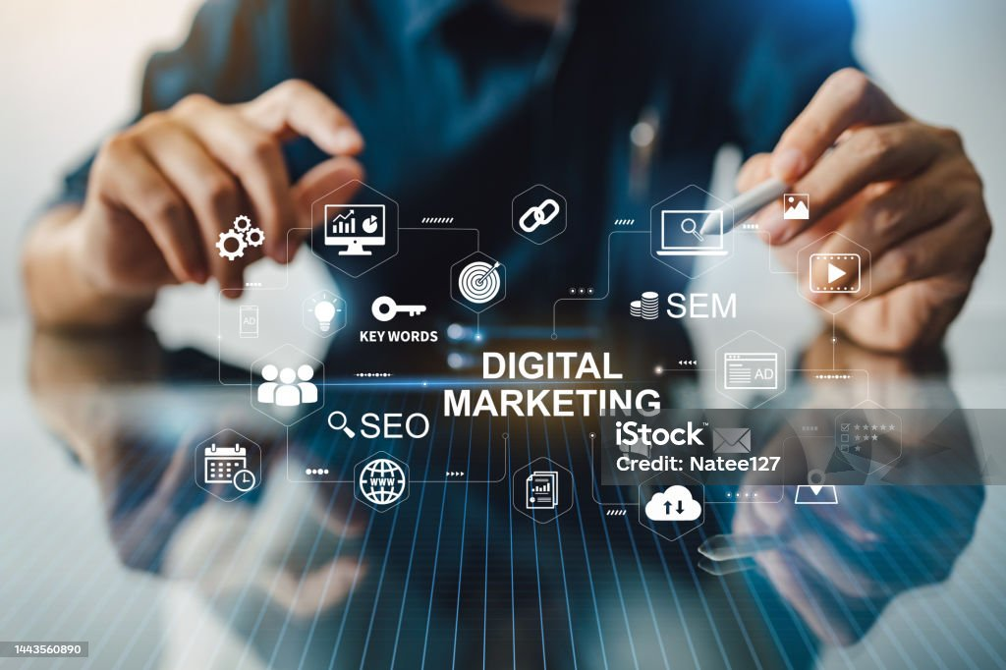

**Wiki of DIGITAL MARKETING**

Digital marketing began to take shape with the rise of the internet and technology in the early 1990s. While it's difficult to pinpoint a single "father" of digital marketing, there are key figures and moments that contributed significantly to its evolution.

**Key Components of Digital Marketing:**

1. **Search Engine Optimization (SEO):**
   * SEO is the practice of optimizing a website or content to rank higher in search engine results pages (SERPs) to increase organic (non-paid) traffic to a website.
2. **Content Marketing:**
   * Content marketing involves creating valuable, relevant, and consistent content to attract and engage a specific audience. It can include blogs, videos, infographics, and more.
3. **Social Media Marketing:**
   * This involves promoting products or services through social media platforms such as Facebook, Instagram, Twitter, LinkedIn, etc. It includes both organic (unpaid) and paid campaigns.
4. **Pay-Per-Click Advertising (PPC):**
   * PPC is an online advertising model where advertisers pay a fee each time their ad is clicked. Google Ads and Facebook Ads are some of the most popular platforms for PPC campaigns.
5. **Email Marketing:**

Email marketing involves sending targeted messages or advertisements to a group of people via email. It’s an effective



Key Components of Digital Marketing:

1. **Search Engine Optimization (SEO):**
   * SEO is the practice of optimizing a website or content to rank higher in search engine results pages (SERPs) to increase organic (non-paid) traffic to a website.
2. **Content Marketing:**
   * Content marketing involves creating valuable, relevant, and consistent content to attract and engage a specific audience. It can include blogs, videos, infographics, and more.
3. **Social Media Marketing:**
   * This involves promoting products or services through social media platforms such as Facebook, Instagram, Twitter, LinkedIn, etc. It includes both organic (unpaid) and paid campaigns.
4. **Pay-Per-Click Advertising (PPC):**
   * PPC is an online advertising model where advertisers pay a fee each time their ad is clicked. Google Ads and Facebook Ads are some of the most popular platforms for PPC campaigns.
5. **Email Marketing:**
   * Email marketing involves sending targeted messages or advertisements to a group of people via email. It’s an effective method for building relationships with potential and existing customers.
6. **Affiliate Marketing:**
   * Affiliate marketing is a performance-based marketing model where an affiliate earns a commission for driving traffic or sales to a merchant's website through their marketing efforts.
7. **Influencer Marketing:**
   * In this form of marketing, businesses partner with influencers (individuals with a large following on social media or other platforms) to promote products or services.
8. **Online Public Relations (PR):**
   * This involves managing a company’s online reputation and maintaining a positive presence across various digital platforms.
9. **Display Advertising:**
   * Display ads are visual-based ads placed on websites, apps, or social media platforms, which can include banner ads, video ads, and other interactive formats.

**Benefits of Digital Marketing:**

* **Cost-Effective:** Compared to traditional marketing methods, digital marketing is often more affordable and offers a greater return on investment (ROI).
* **Global Reach:** Digital marketing allows businesses to reach a global audience, which helps them expand their market.
* **Measurable Results:** With digital marketing, businesses can track their performance in real time, using metrics like clicks, impressions, conversion rates, etc.
* **Targeted Marketing:** Advertisers can segment their audience based on specific criteria like age, location, interests, and behavior, making marketing efforts more effective.
* **Interactivity:** Digital marketing allows brands to engage with consumers directly through social media, comments, and surveys, fostering stronger relationships.

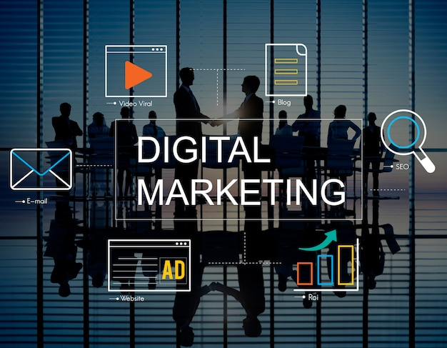

**Challenges in Digital Marketing:**

* **Data Privacy and Security:** With the increasing use of digital platforms, protecting customer data and ensuring privacy has become a key challenge.
* **Rapidly Changing Technology:** As technology evolves quickly, digital marketers need to stay up-to-date with new tools, platforms, and trends.
* **Competition:** The ease of entering the digital space means that businesses face significant competition, especially in crowded sectors.

**Digital Marketing Strategies:**

* **Personalization:** Tailoring marketing efforts to individual consumer preferences to increase engagement.
* **Omni-channel Marketing:** Delivering a consistent message across multiple platforms, whether it's on social media, websites, or email.
* **Video Marketing:** Creating video content that captures attention and communicates a message effectively.
* **Mobile Marketing:** Focusing on marketing efforts that target users on smartphones and tablets

***Here’s a comprehensive digital marketing plan for Livon:***

*Objective Increase brand awareness, drive website traffic, and generate sales for Livon through a multi-channel digital marketing strategy*

**. Target Audience**

*1. *Demographics*: Women and men aged 18-45, middle to upper-middle-class individuals.*

*2. *Interests*: Hair care, beauty, wellness, lifestyle, and fashion.*

*3. *Pain Points*: Hair fall, dandruff, dryness, frizz, and damage.*

Digital Marketing Strategy

Website Optimization*

*1. *Website Redesign*: Create a visually appealing, user-friendly, and mobile-responsive website.*

*2. *SEO Optimization*: Optimize website content, meta tags, and structure for search engines.*

*3. *Page Speed Optimization*: Ensure fast page loading times (less than 3 seconds).*

Content Marketing

*1. *Blog*: Create informative, engaging, and optimized blog posts on hair care, beauty, and wellness topics.*

*2. *Videos*: Produce high-quality, engaging, and informative videos on hair care, product reviews, and tutorials.*

*3. *Infographics*: Design visually appealing and informative infographics on hair care tips, product benefits, and more*

***\*Social Media Content*:***

*Create engaging, informative, and optimized social media content*

**. * Social Media Marketing\***

\**Platform Selection*: Focus on Instagram, Facebook, Twitter, and YouTube*

*. 2. *Content Strategy*: Share a mix of promotional, educational, and engaging content.*

*3. *Influencer Collaboration*: Partner with influencers in the beauty and hair care niches.*

*4. *Paid Advertising*: Run targeted social media ads to increase brand awareness and drive website traffic.*

**\* Email Marketing\***

*1. *Email List Building*: Create a sign-up form on the website and offer incentives for subscribers*

*. 2. *Newsletter*: Send a monthly newsletter with exclusive promotions, new product launches, and hair care tips.*

*3. *Abandoned Cart Emails*: Send reminders to customers who abandoned their shopping carts.*

**\*Search Engine Optimization (SEO)\***

*1. *Keyword Research*: Conduct thorough keyword research to identify relevant terms.*

*2. *On-Page Optimization*: Optimize website content, meta tags, and structure for search engines.*

*3. *Link Building*: Build high-quality backlinks from relevant websites*.

**\*Paid Advertising\***

*1. *Google Ads*: Run targeted Google Ads to drive website traffic and generate sales.*

*2. *Facebook Ads*: Run targeted Facebook Ads to increase brand awareness and drive website traffic.*

*3. *Influencer Advertising*: Partner with influencers to promote Livon products.*

**\* Influencer Marketing\***

*1. *Influencer Research*: Identify and research influencers in the beauty and hair care niches.*

*2. *Influencer Collaboration*: Partner with influencers to promote Livon products.*

*3. *Influencer Takeovers*: Invite influencers to take over Livon’s social media* a

**Timeline Quarter 1 (January-March): -**

*Website optimization - Content marketing strategy development - Social media marketing campaign launch*

**Quarter 2 (April-June):**

*Email marketing campaign launch*

*SEO optimization –*

*Paid advertising campaign launch*

**Quarter 3 (July-September): -**

*Influencer marketing campaign launch - Content marketing campaign optimization - Social media marketing campaign optimization*

*Quarter 4 (October-December): -*

*Analyze results and adjust strategies - Plan for future campaigns and activations*

**Brand Study**

*1. *Brand Identity*: Analyze your brand’s values, mission, vision, and unique value proposition.*

*2. *Brand Image*: Examine how your target audience perceives your brand, including its strengths, weaknesses, and overall reputation.*

*3. *Brand Positioning*: Identify your brand’s unique position in the market, including its competitive advantages and differentiators.*

**Competitor Analysis**

*1. *Identify Competitors*: Determine your main competitors, including direct and indirect competitors.*

*2. *Competitor Profiling*: Gather information about each competitor, including their:*

*1. *Brand Identity*: Values, mission, vision, and unique value proposition.*

*2. *Market Position*: Target audience, market share, and competitive advantages.*

*3. *Product/Service Offerings*: Features, benefits, and pricing.*

**. *Marketing Strategies*:**

*Advertising, content marketing, social media, and other tactics.*

**\*Competitive Landscape*:**

*Analyze the competitive landscape, including market trends, opportunities, and threats.*

\***SWOT Analysis**\*: *Conduct a SWOT analysis (Strengths, Weaknesses, Opportunities, and Threats) for each competitor.*

**Demographics**

*1. *Age*: What is their age range?*

*2. *Gender*: What is their gender identity?*

*3. *Income*: What is their annual income or household income?*

*4. *Occupation*: What is their profession or job title?*

*5. *Education*: What is their level of education?*

*6. *Marital Status*: Are they single, married, divorced, or widowed?*

*7. *Family Size*: How many people are in their household?*

**SEO**

SEO (Search Engine Optimization) and keyword research are crucial for improving your website’s visibility, driving organic traffic, and increasing conversions. Here’s a comprehensive outline:

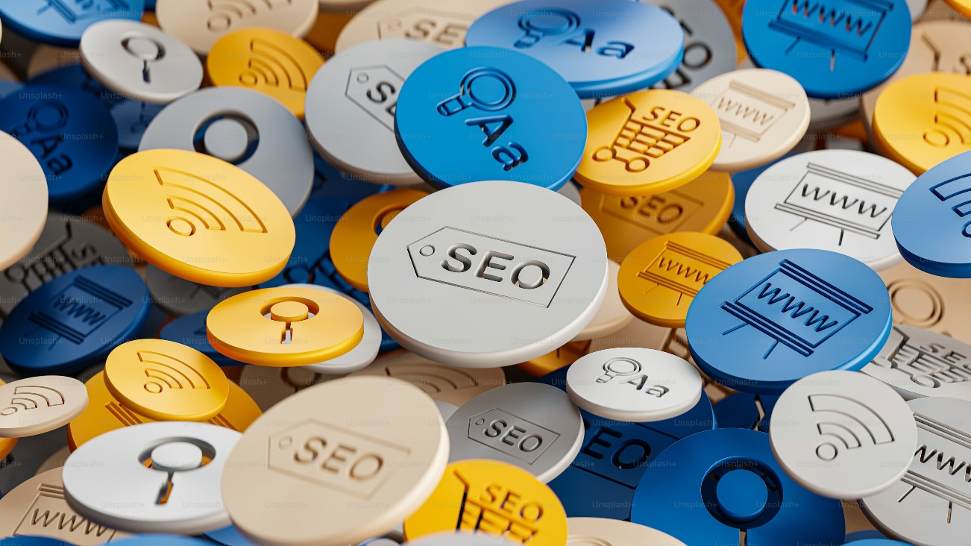

***SEO Fundamentals***

*1. *Crawling*: Search engines crawl websites to discover and index content.*

*2. *Indexing*: Search engines store crawled content in massive databases called indexes.*

*3. *Algorithms*: Search engines use algorithms to rank content based on relevance, authority, and user experience.*

*4. *Keyword Research*: Identify relevant keywords and phrases to optimize your content.*

**Keyword Research**

*1. *Brainstorming*: Identify seed keywords related to your business, product, or service.*

*2. *Keyword Tools*: Utilize tools like Google Keyword Planner, Ahrefs, SEMrush, or Moz Keyword Explorer to: - Analyze search volume and competition - Identify long-tail keywords and phrases - Discover related keywords and topics*

*3. *Keyword Filtering*: Filter keywords based on relevance, search volume, and competition. On-Page Optimization*

*1. *Title Tags*: Write unique, descriptive, and keyword-rich title tags.*

*2. *Meta Descriptions*: Craft compelling and informative meta descriptions.*

*3. *Header Tags*: Organize content with header tags (H1, H2, H3,*

*etc.).*

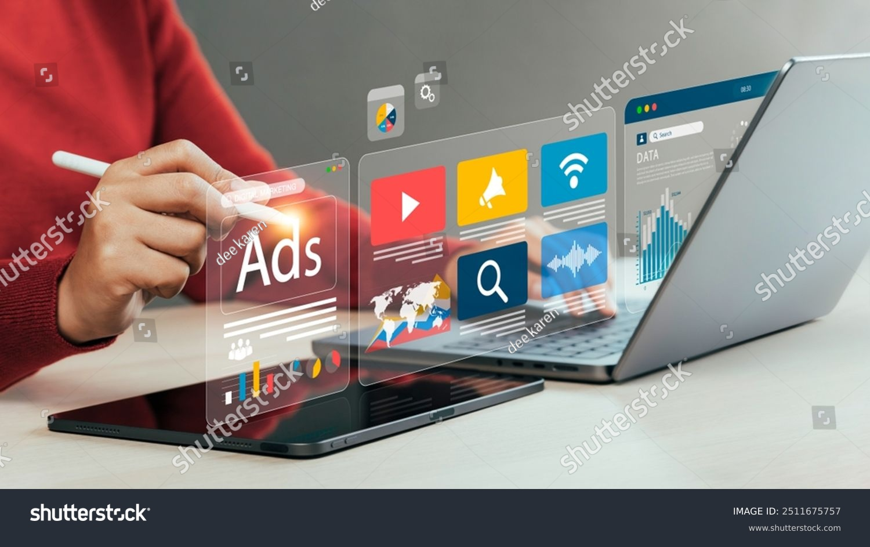

**4. *Content Optimization*:**

*Use keywords naturally throughout high-quality, engaging content.*

*5. *URL Structure*: Use descriptive, keyword-rich URLs.*

*6. *Image Optimization*: Optimize images with descriptive alt tags and file names. Technical Optimization*

*1. *Page Speed*: Ensure fast page loading times (less than 3 seconds).*

*2. *Mobile-Friendliness*: Ensure a responsive, mobile-friendly design.*

*3. *SSL Encryption*: Install an SSL certificate to secure your website.*

*4. *XML Sitemaps*: Create and submit XML sitemaps to help search engines understand your website’s structure.*

*5. *Robots.txt*: Optimize your robots.txt file to control crawling and indexing. Link Building*

*1. *High-Quality Content*: Create linkable assets like eBooks, whitepapers, and infographics.*

*2. *Guest Blogging*: Write guest posts for reputable websites in your niche.*

*3. *Broken Link Building*: Find and replace broken links with your own content.*

*4. *Resource Pages*: Create resource pages that link to other high-quality websites*

*. 5. *Reviews*: Encourage customers to review your business or product. Local SEO*

**1. *Google My Business*: Claim and optimize your Google My Business listing.**

*2. *Local Citations*: Get listed in local directories and citations.*

*3. *Location-Specific Content*: Create content that targets specific locations.*

*4. *Schema Markup*: Use schema markup to highlight local business information.*

**Marketing Strategies**



*1. *Influencer Marketing*: Partner with influencers in your industry to promote your brand, product, or service.*

*2. *Email Marketing*: Build an email list and create campaigns to nurture leads, promote products, and build brand awareness.*

*3. *Content Marketing*: Create and distribute valuable, relevant, and consistent content to attract and retain a clearly defined audience*

*. 4. *Social Media Marketing*: Use social media platforms to build brand awareness, engage with customers, and drive website traffic and sales.*

*5. *Paid Advertising*: Use paid advertising channels like Google Ads, Facebook Ads, and LinkedIn Ads to reach your target audience and drive conversions.*

*6. *SEO*: Optimize your website and content to rank higher in search engine results pages (SERPs) and drive organic traffic.*

*7. *Referral Marketing*: Encourage happy customers to refer their friends and family in exchange for incentives and rewards.*

*8. *Affiliate Marketing*: Partner with affiliates who promote your product or service in exchange for a commission on sales*

*. 9. *Event Marketing*: Host events, webinars, and conferences to build brand awareness, generate leads, and drive sales.*

*10. *Account-Based Marketing*: Focus on targeting specific accounts and decisionmakers with personalized content and messaging.*

**Measurement and Analysis**

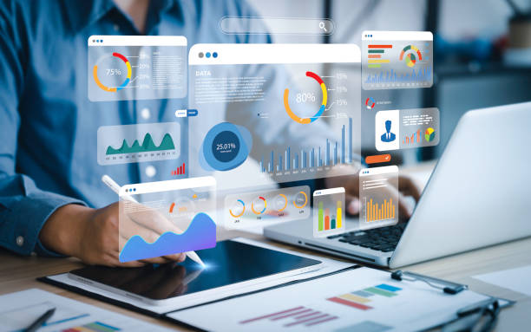

*1. *Track Website Analytics*: Use tools like Google Analytics to track website traffic, engagement, and conversion metrics.*

*2. *Monitor Social Media Metrics*: Use social media analytics tools to track engagement, reach, and conversion metrics.*

*3. *Measure Email Marketing Metrics*: Use email marketing analytics tools to track open rates, click-through rates, and conversion metrics.*

*4. *Conduct A/B Testing*: Conduct A/B testing to compare the performance of different content variations.*

*5. *Use Heat Maps and Session Recordings*: Use heat maps and session recordings to analyze user behavior and identify areas for improvement.*

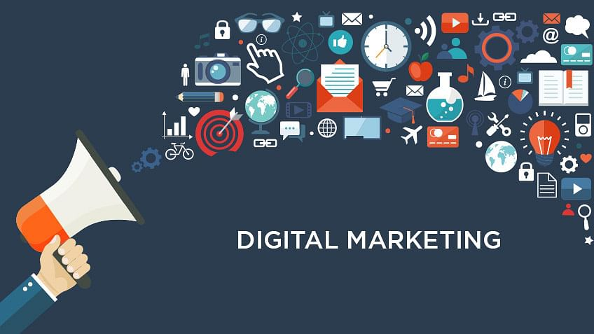

**Conclusion:**

*Digital marketing continues to evolve with new trends, tools, and technologies. It offers immense opportunities for businesses to grow their brand presence and connect with a wider audience while allowing for more precise and efficient marketing strategies. As digital platforms continue to dominate the way consumers engage with brands, digital marketing is an essential component of modern business strategies*

*Project by*

*Jahnavi Telugu*